Computational Finance Project 7

Nitish Ramkumar

1)

a)

The values for European Option put using the different methods and different dt order for S0 = 10 are as follows:

|  |  |  |
| --- | --- | --- |
| **Method** | **dtOrder** | **Price of European Put** |
| Explicit | 1 | 0.464541 |
| Explicit | 3 | 0.463417 |
| Explicit | 4 | 0.463142 |
| Implicit | 1 | 0.463406 |
| Implicit | 3 | 0.462855 |
| Implicit | 4 | 0.462579 |
| Crank-Nicolson | 1 | 0.463686 |
| Crank-Nicolson | 3 | 0.463136 |
| Crank-Nicolson | 4 | 0.462861 |
| Black Scholes |  | 0.464695 |

b) The prices for the various types and the different orders of dX are as below

|  |  |  |  |  |  |  |  |  |  |  |
| --- | --- | --- | --- | --- | --- | --- | --- | --- | --- | --- |
| **S0** | **EFD_dt** | **EFD_3dt** | **EFD_4dt** | **IFD_dt** | **IFD_3dt** | **IFD_4dt** | **CNF_dt** | **CNF_3dt** | **CNF_4dt** | **BlackScholes** |
| 4 | 5.787 | 5.794 | 5.787 | 4.639 | 5.632 | 5.721 | 4.608 | 5.630 | 5.721 | 5.802 |
| 5 | 4.781 | 4.745 | 4.735 | 4.759 | 4.744 | 4.735 | 4.758 | 4.744 | 4.735 | 4.802 |
| 6 | 3.797 | 3.712 | 3.743 | 3.797 | 3.712 | 3.743 | 3.797 | 3.712 | 3.743 | 3.802 |
| 7 | 2.751 | 2.804 | 2.689 | 2.752 | 2.804 | 2.689 | 2.752 | 2.804 | 2.689 | 2.805 |
| 8 | 1.783 | 1.799 | 1.782 | 1.783 | 1.799 | 1.783 | 1.783 | 1.799 | 1.783 | 1.844 |
| 9 | 0.980 | 0.946 | 0.925 | 0.980 | 0.946 | 0.925 | 0.980 | 0.946 | 0.925 | 1.024 |
| 10 | 0.465 | 0.463 | 0.463 | 0.463 | 0.463 | 0.463 | 0.464 | 0.463 | 0.463 | 0.465 |
| 11 | 0.164 | 0.145 | 0.147 | 0.164 | 0.145 | 0.147 | 0.164 | 0.145 | 0.147 | 0.172 |
| 12 | 0.048 | 0.049 | 0.041 | 0.048 | 0.049 | 0.041 | 0.048 | 0.049 | 0.041 | 0.052 |
| 13 | 0.012 | 0.013 | 0.012 | 0.012 | 0.013 | 0.012 | 0.012 | 0.013 | 0.012 | 0.014 |
| 14 | 0.003 | 0.003 | 0.003 | 0.003 | 0.003 | 0.003 | 0.003 | 0.003 | 0.003 | 0.003 |
| 15 | 0.001 | 0.000 | 0.001 | 0.001 | 0.000 | 0.001 | 0.001 | 0.000 | 0.001 | 0.001 |
| 16 | 0.000 | 0.000 | 0.000 | 0.000 | 0.000 | 0.000 | 0.000 | 0.000 | 0.000 | 0.000 |

The error percentage for all these prices by comparing it with black scholes is as follows:

|  |  |  |  |  |  |  |  |  |  |
| --- | --- | --- | --- | --- | --- | --- | --- | --- | --- |
| **S0** | **EFD_dt** | **EFD_3dt** | **EFD_4dt** | **IFD_dt** | **IFD_3dt** | **IFD_4dt** | **CNF_dt** | **CNF_3dt** | **CNF_4dt** |
| 4 | -0.26% | -0.14% | -0.26% | -20.05% | -2.93% | -1.40% | -20.57% | -2.96% | -1.40% |
| 5 | -0.45% | -1.19% | -1.39% | -0.90% | -1.20% | -1.39% | -0.91% | -1.20% | -1.39% |
| 6 | -0.14% | -2.38% | -1.56% | -0.14% | -2.38% | -1.56% | -0.14% | -2.38% | -1.56% |
| 7 | -1.92% | -0.06% | -4.15% | -1.91% | -0.06% | -4.14% | -1.92% | -0.06% | -4.15% |
| 8 | -3.34% | -2.47% | -3.35% | -3.33% | -2.45% | -3.33% | -3.34% | -2.46% | -3.34% |
| 9 | -4.36% | -7.62% | -9.73% | -4.33% | -7.64% | -9.75% | -4.32% | -7.63% | -9.74% |
| 10 | -0.03% | -0.27% | -0.33% | -0.28% | -0.40% | -0.46% | -0.22% | -0.34% | -0.39% |
| 11 | -4.30% | -15.47% | -14.38% | -4.23% | -15.62% | -14.53% | -4.14% | -15.54% | -14.46% |
| 12 | -9.37% | -6.41% | -21.15% | -8.81% | -6.27% | -20.95% | -8.88% | -6.34% | -21.05% |
| 13 | -11.48% | -3.53% | -12.05% | -10.89% | -2.32% | -10.86% | -11.49% | -2.92% | -11.45% |
| 14 | -9.14% | -11.24% | -9.10% | -6.62% | -7.91% | -5.75% | -8.30% | -9.57% | -7.42% |
| 15 | -17.09% | -29.71% | -15.75% | -11.40% | -23.68% | -9.06% | -14.76% | -26.69% | -12.41% |
| 16 | -18.70% | -27.84% | -31.85% | -5.23% | -17.03% | -21.58% | -11.34% | -22.47% | -26.75% |

1. The error percentage reduces as we decrease dX for the Implicit and Crank Nicolson methods (except for S0 = 4). So, there is unconditional convergence for both the methods.
2. The OTM put option errors are higher because they are very small numbers
3. In general, the prices are very similar for ITM put options for all types and dx.
4. External with dx = $σ √dt$ case, has errors moving around a lot (in one case it is very low error and in the next case it is very high). This shows that this case isn’t stable.

2)

The American call and American put prices using dS = 0.5 are as below

|  |  |
| --- | --- |
| **Explicit_Call** | 0.652503 |
| **Explicit_Put** | 0.472490 |
| **Implicit_Call** | 0.651897 |
| **Implicit_Put** | 0.471615 |
| **Crank-Nicolson_Call** | 0.652200 |
| **Crank-Nicolson_Put** | 0.472051 |

These values match expected values out of binomial and trinomial models from previous homeworks.

The American call and American put prices using dS = 1 are as below

|  |  |
| --- | --- |
| **Explicit_Call** | 0.621424 |
| **Explicit_Put** | 0.439066 |
| **Implicit_Call** | 0.620664 |
| **Implicit_Put** | 0.438166 |
| **Crank-Nicolson_Call** | 0.621044 |
| **Crank-Nicolson_Put** | 0.438616 |

The value becomes less accurate with increase in dS.

b)

We can plot values from Explicit, Implicit and Crank-Nicolson for American call and puts for current stock prices from 4 to 16.

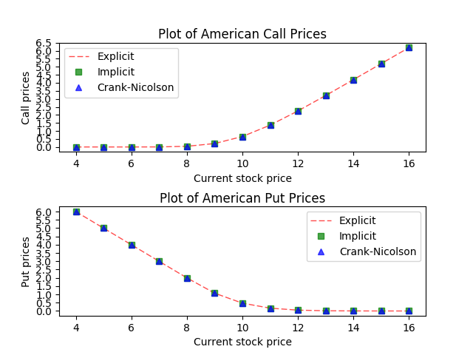

It can be noticed that American call and put prices are very similar for 3 methods.